Data Analytics Internship Assignment

Project Explanation Document

# Data Manipulation and Report Dash boarding

Author: Kalyani M U

Date: 07-March-2024

# Introduction

Welcome to the Data Analytics Internship Assignment with ERP Launchpad! This project aims to data manipulation and report dash boarding, analysing and interpreting data effectively in the manufacturing industry. This assignment, process of extracting, transforming, and visualizing data to drive informed decision-making.

Throughout this document, you'll find detailed explanations and screenshots demonstrating the steps taken to complete the assigned tasks. From filtering and sorting data to creating insightful report dashboards.

# Objectives:

Data Manipulation Tasks:

Task 1: Create a new sub-sheet containing data from the "Data Set" sheet based on specified criteria using the Query Function.

Task 2: Utilize Vlookup with ArrayFormula to populate Industry and NSE/BSE Code columns dynamically, incorporating IF conditions for efficient data handling.

Task 3: Calculate Bear Mode 1 and Bear Mode 2 based on percentage changes from 52-week High and Low, and determine Stock Status using multiple IF conditions.

Task 4: Identify the highest value of Market Cap and categorize stocks into Large, Medium, and Low Cap based on specified thresholds.

Task 5: Create a new sheet containing data for 'Good Stock' and apply proper formatting and conditional formatting for enhanced visualization.

# Report Dashboarding:

Task 1: Connect the Data Source Sheet to Google Data Studio and develop comprehensive report dashboards with appropriate filters and visualizations.

Task 2: Provide meaningful analysis and insights in the report dashboards, demonstrating your understanding of the data set and its implications for business decisions.

# Task 1: Data Manipulation .

# Picture 1: Original Data Set

# 

Description: Screenshot of the original "Data Set" sheet .

# Picture 2: Filtered Data Set

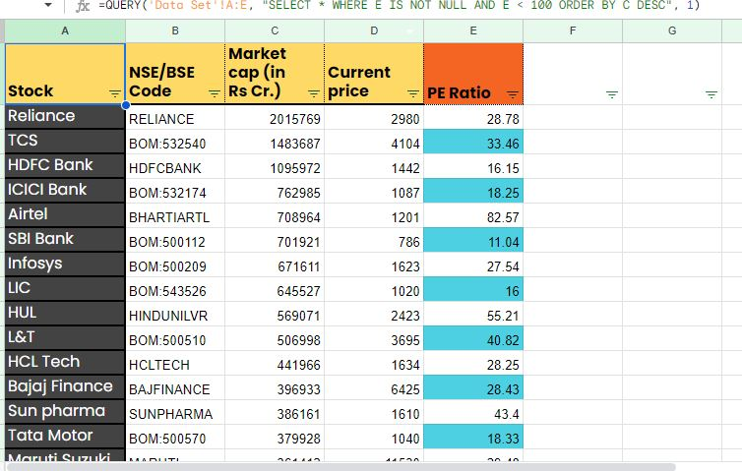

Description: Screenshot of the new sub sheet created using the QUERY function to filter data where PE Ratio is not blank and less than 100, sorted by descending Market Cap amount.

# Task 2: Vlookup and ArrayFormula

# Picture 3: Adding Industry and NSE/BSE Code Columns

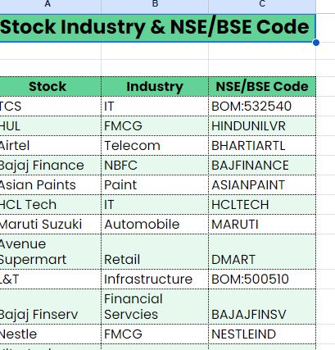

Description: Screenshot of adding Industry and NSE/BSE Code columns .

# Task 3: Bear Mode Columns 3.1.

# Picture 4: Bear Mode 1 Calculation

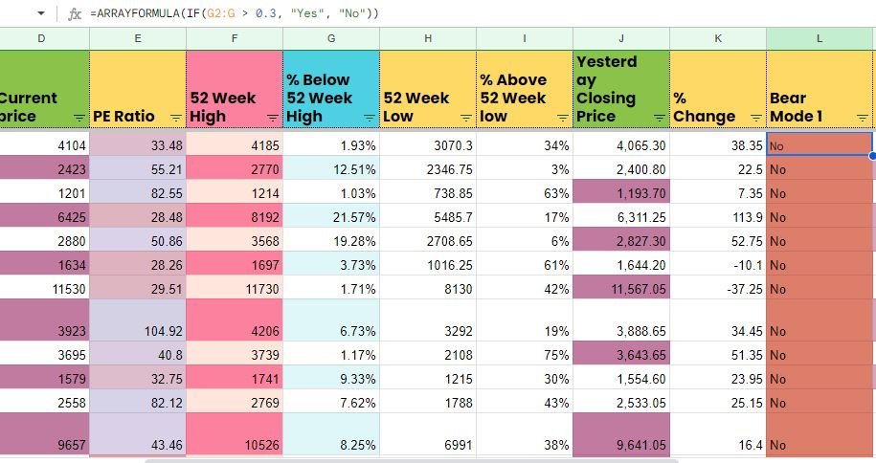

Description: Screenshot illustrating the application of IF conditions to determine Bear Mode 1 status based on % change from 52 Week High.

# 3.2. Picture 5: Bear Mode 2 Calculation

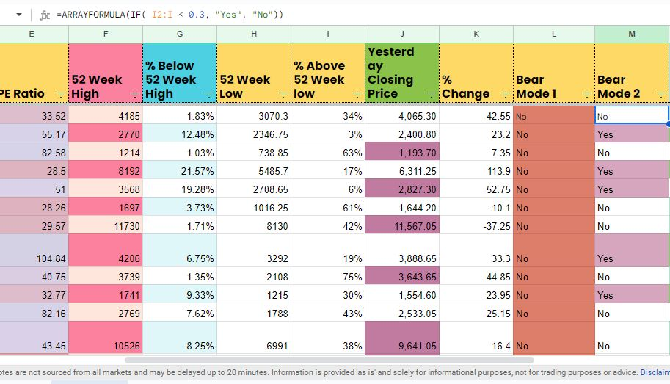

Description: Screenshot illustrating the application of IF conditions to determine Bear Mode 2 status based on % change from 52 Week Low.

# Task 4: Categorizing Market Cap

# 4.1. Picture 6: Market Cap Categorization

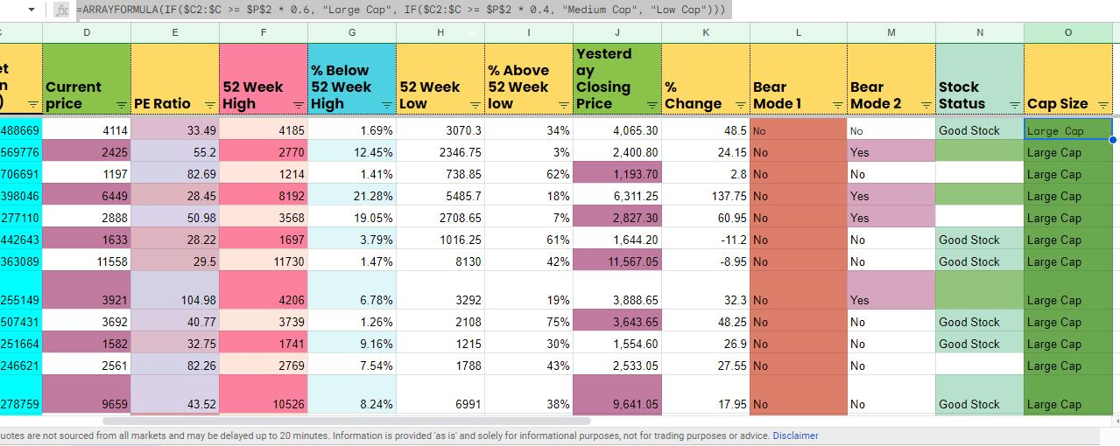

Description: Screenshot of categorizing market cap into Large, Medium, and Low Cap stocks based on the highest value of Market Cap.

# Task 5: Final Organized Data Source .

# Picture 7: Final Organized Data Source

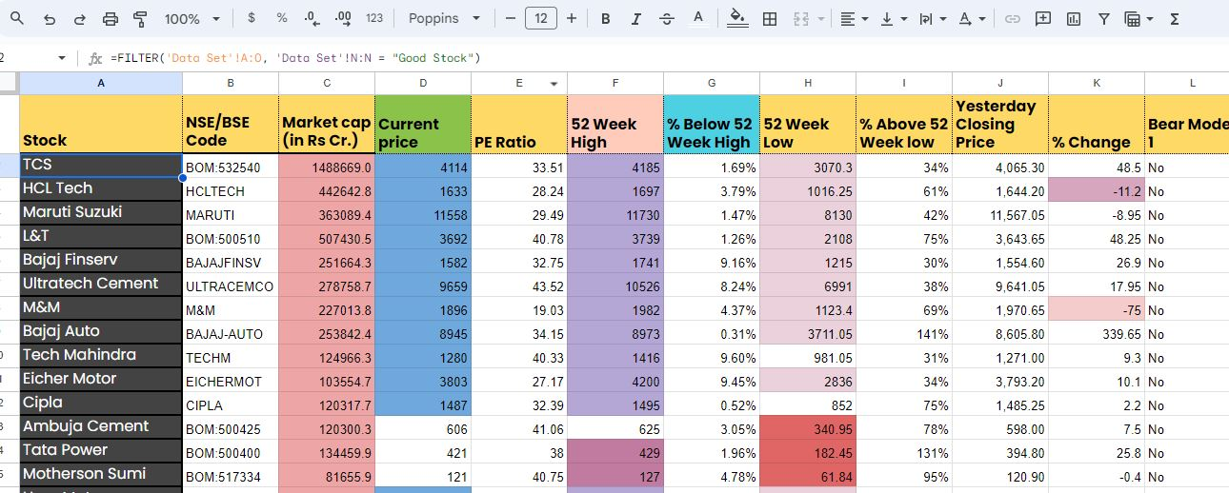

Description: Screenshot of the new sheet with filtered data where Stock Status is 'Good Stock' and proper formatting applied.

# Task 6: Report Dashboarding .

# Picture 8: Connecting Data Source to Google Data Studio

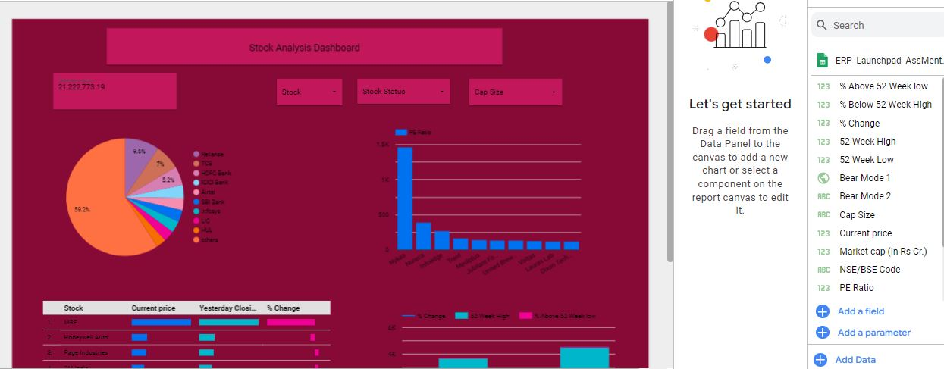

Description: Screenshot of connecting the Data Source Sheet to Google Data Studio for report dashboarding.

# 6.2. Picture 9: Report Dashboard

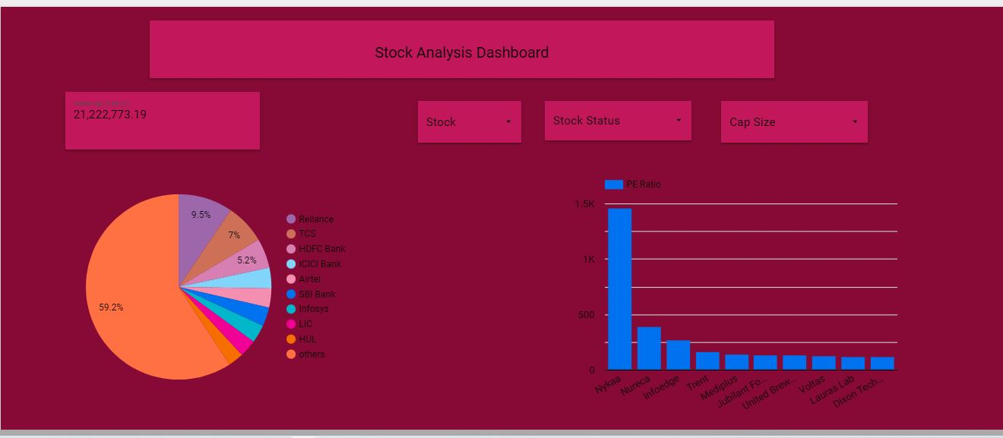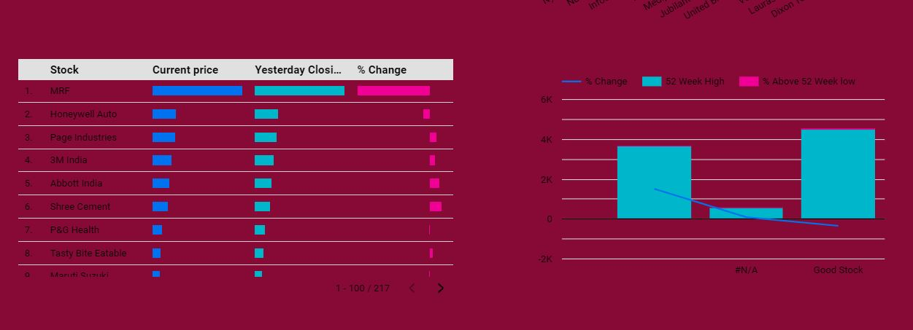

Description: Screenshot of the report dashboard created in Google Data Studio, including various charts and filters.

# Conclusion:

In conclusion, this project has provided a comprehensive exploration of data manipulation and report dashboarding techniques using Google Sheets and Google Data Studio. Throughout the assignment, we successfully completed a series of tasks aimed at extracting, transforming, and visualizing data from the provided dataset.

We began by filtering and sorting data based on specific criteria, such as PE Ratio and Market Cap, to create organized sub-sheets. Through the implementation of advanced formulas like Query Function and Vlookup with ArrayFormula, we efficiently populated additional columns and calculated key metrics such as Bear Mode indicators and Stock Status.

Furthermore, we categorized stocks into different cap sizes based on Market Cap thresholds, enabling us to gain insights into the distribution of companies within the market. Additionally, we created a visually appealing report dashboard in Google Data Studio, showcasing various charts, scorecards, and filters to facilitate data analysis and decision-making.

Overall, this project has not only enhanced our proficiency in data manipulation and visualization but has also provided valuable insights into the dynamics of the manufacturing industry. By leveraging the power of data analytics, we are better equipped to derive actionable insights and drive informed business decisions in the future.

Links:

1.<https://docs.google.com/spreadsheets/d/1rYOn-wCgvzWtiyTa--ThEOG_m1gEs2z2Ey_YHKCyAI0/edit?usp=sharing>

2. https://lookerstudio.google.com/reporting/8bb57f78-fb9d-4746-bcc1-ae7f3210cd02

Top of Form

Let me know if you need further assistance!

Best regards,

Kalyani m u

Kalyani.utla@gmail.com